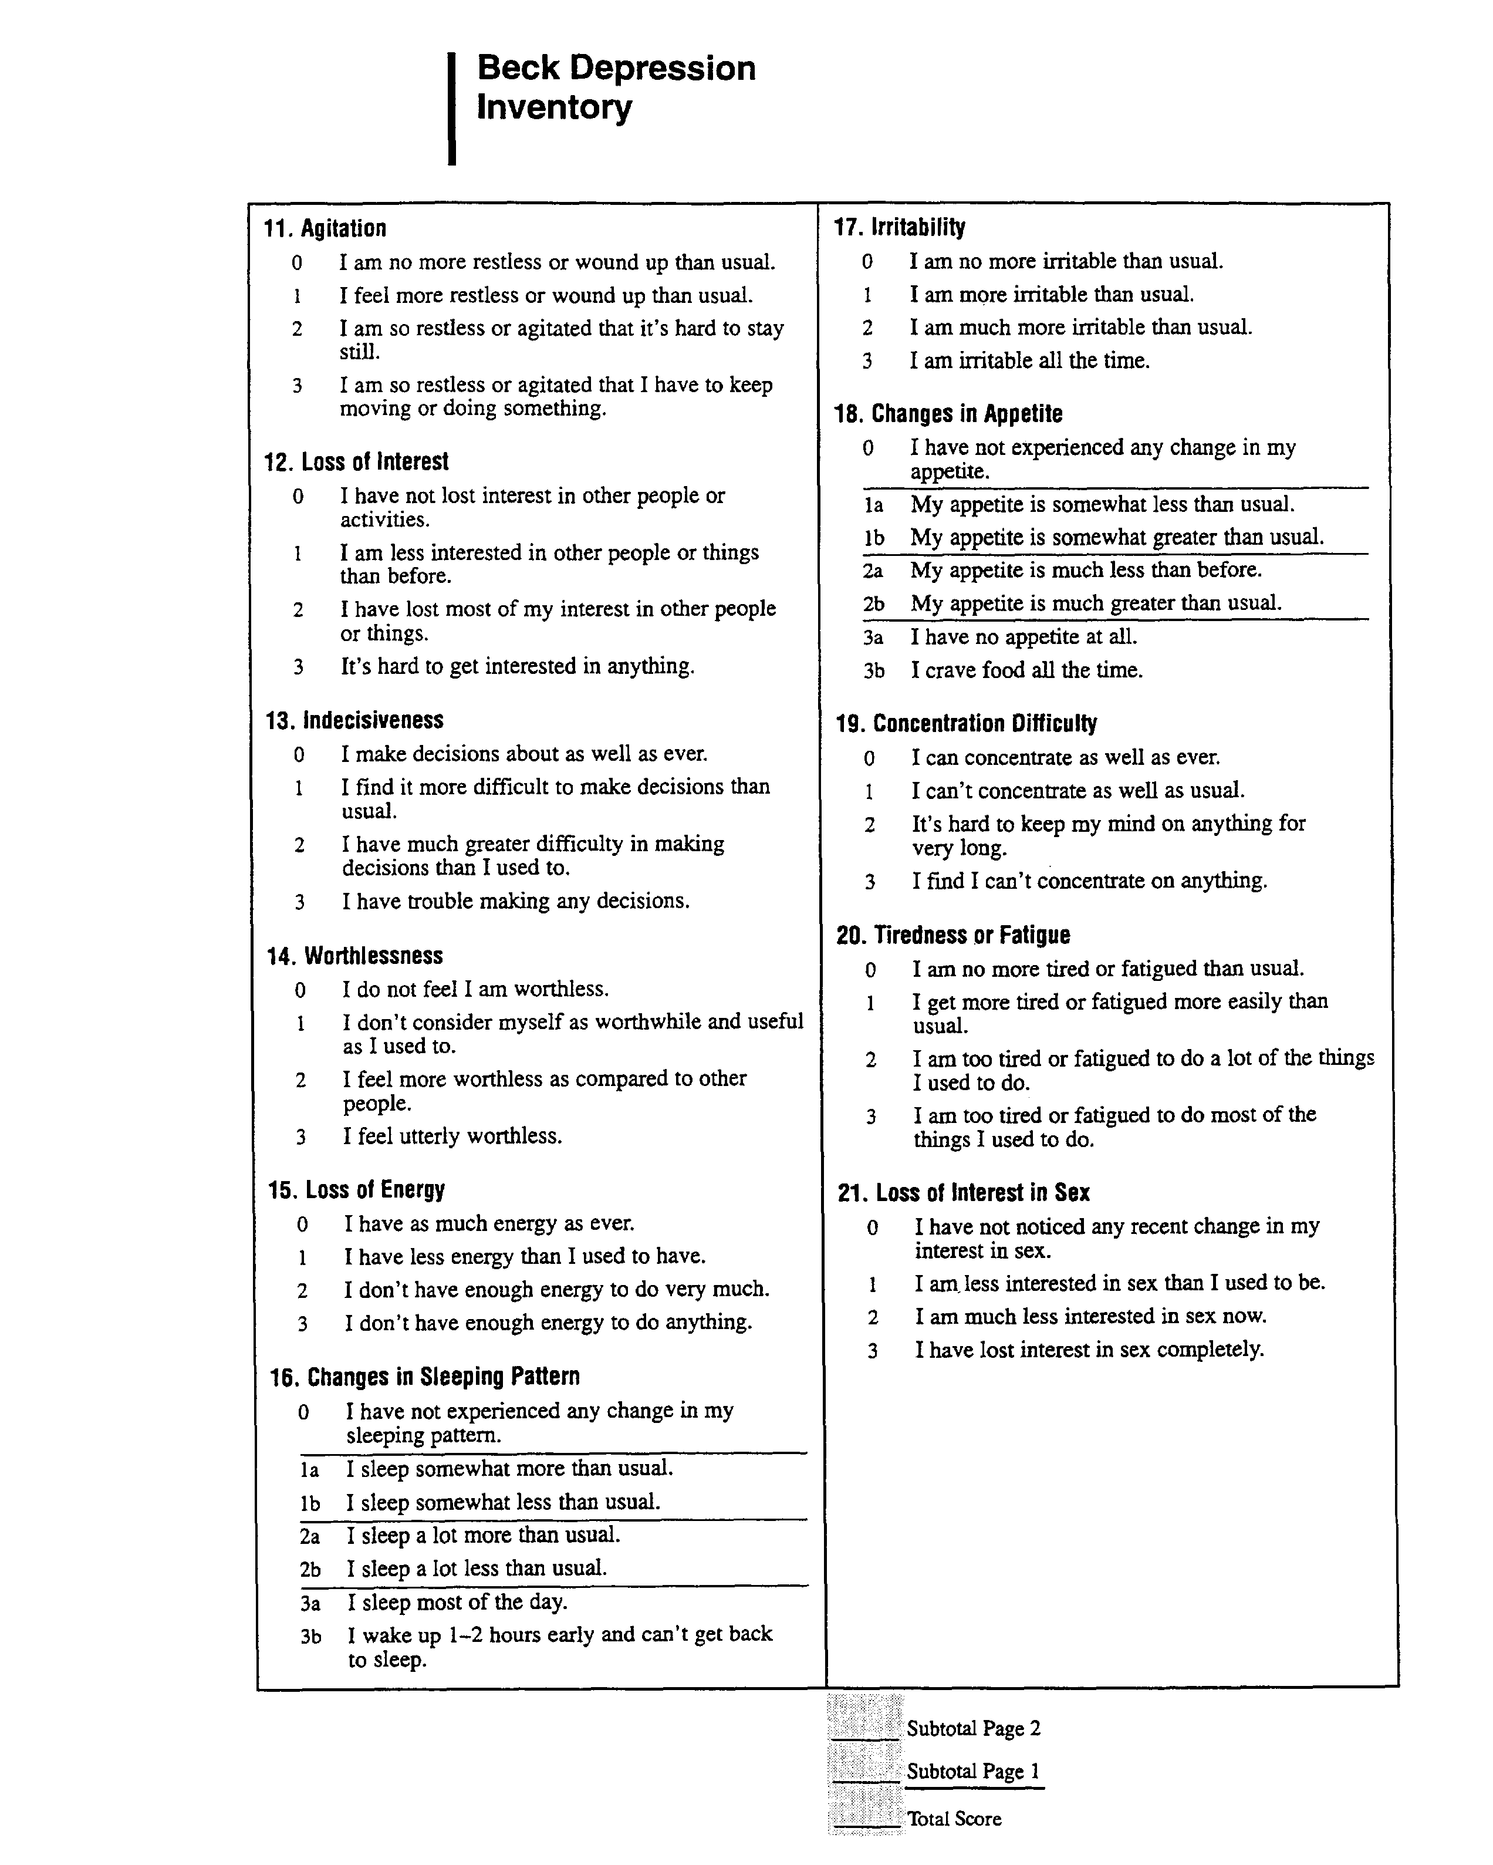

Scoring the Beck Depression Inventory
After the patient has completed the test, add up the score for each of the 21 questions and obtain the total score.
The highest score for each of the twenty-one questions is three, the highest possible total for the whole test would be sixty-three if the patient marked number 3 on all the questions. The lowest score for each question is zero, so the lowest possible score for the test would be zero if the patient marked zero on each question. The following chart indicates the relationship between total score and level of depression.

Clasification | Total Score | Level of Depression
Low | 1-10 | These ups and downs are considered normal
 | 11-16 | Mild mood disturbance
Moderate | 17-20 | Borderline clinical depression
 | 21-30 | Moderate depression
Significant | 31-40 | Severe depression
 | Over 40 | Extreme depression
A persistent score of 17 or above indicates you may need professional treatment.

